Watch out…



Omar Ahmed Hussein (40)  
Basem Mohamed  
Design pattern Game

# the game in lines

An application applying several design patterns in action besides a game logic, which is the mean aim of using design patterns in real apps to find out its importance.

# watch out game

Watch out is a two player-game in which every player carries two stacks of

Plates, and there are several colored plates falling down and he tries to catch

Them, if he manages to collect three consecutive plates of the same color, then

They are vanished and his score increases, the player who gets more score at less time wins.

Design pattern

### MVC

* Game Model
* The game model holds the every object of the game and it’s members are
* Player one
* Player two
* The four moving belts
* Shapes pool
* Falling area

These are the main components of the game and it implements drawable to draw all it’s components, the game model mainly has three update functions (besides the setters and getters) which are

Update: every time these method is called every thing is updated the shapes it’s position and score and belts movement every thing in the game logic is updated

Update player by mouse: update the player position and observe the shape that player holds of that change

Update player by keyboard: update the player position and observe the shapes that the player holds of that change

* Game View
  + The game view is a GUI interface that draws the game on a jfarme and render it on every update and it gets the drawable list from the model and draw it
* Game controller
  + It has the model and the view and the model inside of it and control over both of them it listen to the mouse and the keyboard movement and send the data to the model and receive the update from the model and then send the data to the view to draw it.

### observer pattern

* Observer design pattern observe is over the player so that it when the player updates it’s position it observe the shapes in his two hands to update their position according to the player movement also it uses the iterator design pattern to iterate over the shapes in the player hands.

### pool pattern

* All the idea about Pool design pattern is just making a limited number of objects and make limits to the app not to create objects as it wants because so far there is a limit to the memory and also in order to make efficient usage of what we create the when we finish the usage of an object just return it into the pool

### iterator pattern

* The iterator design pattern mission is to iterate over the any kind of data structure stacks, arrays, list, queues without caring about the kind of the data structure

### state pattern

* State pattern used twice in the game
  + Shape state
    - Shape is on the line
    - Shape is in the falling area
    - Shape is not visual (in the pool)
    - Shape is with the player
  + Belt State
    - Line length is increasing
    - Line length is decreasing

### singleton pattern

* Used in making only one model and one view while the game is running in order to guarantee there is only one view.

Game user guide

The Game is very easy to explain it is a two player-game in which every player carries two stacks of Plates, and there are several colored plates falling down and he tries to catch Them, if he manages to collect three consecutive plates of the same color, then They are vanished and his score increases, the player who gets more score at less time wins.

The main menu has two options

* Start new game
* 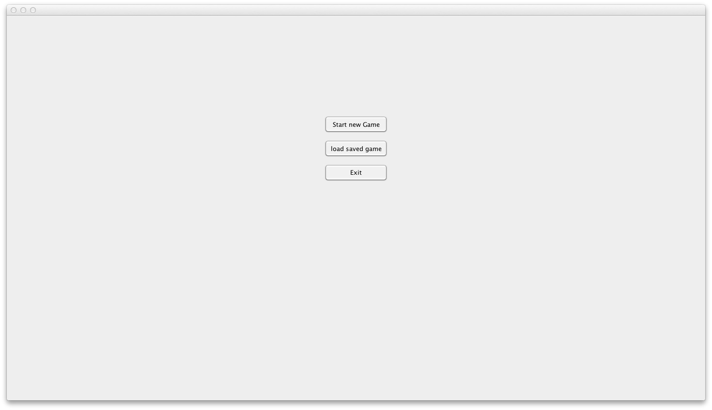Load a saved game

One player plays with the mouse and the other plays with the arrow keys at keyboard and the game screen will be like these

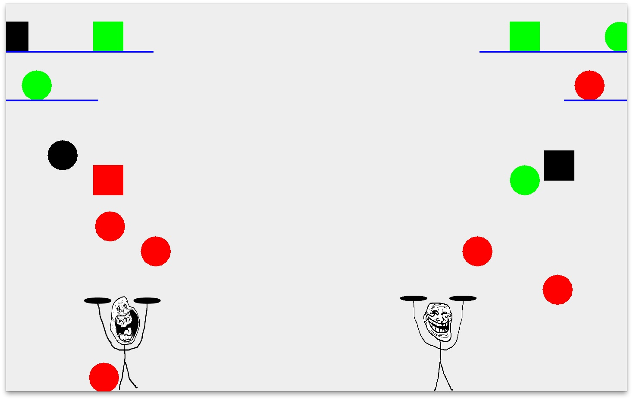

As you can save or load your games easily by pressing ESC button and save game.